The steelpan, Trinidad and Tobago’s national instrument, was born in the 1930s from Carnival traditions and community innovation, evolving from bamboo percussion to finely tuned steel drums. It symbolizes resilience, creativity, and cultural pride, now celebrated globally with events like World Steelpan Day.

📜 Early Roots
- 1700s–1800s: Enslaved Africans brought strong drumming traditions to Trinidad. After emancipation in 1834-38, African-descended communities used percussion in Carnival, though colonial authorities often restricted drumming.
- 1890s: Tamboo bamboo ensembles emerged, using bamboo sticks of varying lengths to mimic musical voices (soprano, alto, tenor, bass). These became central to Carnival street music. mittcott.com

🔨 Transition to Metal
- 1930s–1940s: Bamboo was gradually replaced by metal objects—garbage bins, biscuit tins, paint cans, brake drums, and other discarded items. These “metal bands” created louder, more resonant sounds. mittcott.com
- Innovators like Ellie Mannette began experimenting with tuning oil drums, hammering the surfaces to create distinct pitches. This marked the birth of the modern steelpan. Google Arts & Culture

🎶 Formal Development
- 1940s–1950s: Steelbands became organized, with instruments tuned to scales and capable of playing melodies and harmonies.
- 1950s onward: The instrument gained recognition beyond Carnival, entering concert halls and international festivals.

🇹🇹 National Recognition
- 1992: Declared the official national instrument of Trinidad and Tobago by Prime Minister Patrick Manning. Wikipedia
- 2023: The United Nations General Assembly proclaimed August 11 as World Steelpan Day, highlighting its global cultural significance. Wikipedia

🌍 Global Impact
- Steelpan spread internationally through migration of Trinidadians and their Carnival culture, especially in London’s Notting Hill Carnival and competitions like Panorama. Google Arts & Culture
- Today, pannists perform worldwide, and the instrument is taught in schools and universities, symbolizing Trinidad and Tobago’s creative legacy.

✨ Key Takeaways
- Invented in Trinidad and Tobago in the 20th century, making it one of the few acoustic instruments created in modern times.
- Evolved from bamboo → metal → tuned oil drums.
- Embodies Carnival, resistance, innovation, and national pride.
- Globally recognized, with dedicated festivals and international competitions.

🥁 Steelpan History Timeline – Trinidad & Tobago
Period | Key Developments | Notes
1700s–1800s | African drumming traditions brought by enslaved Africans | Carnival celebrations centered on percussion, despite colonial restrictions.
1834 (Emancipation) | Freed communities continued drumming in Carnival | Authorities often banned drums, leading to creative alternatives.
1890s | Tamboo bamboo ensembles emerged | Bamboo sticks of varying lengths imitated musical voices (soprano, alto, tenor, bass).
1930s–1940s | Transition from bamboo to metal objects | Biscuit tins, paint cans, brake drums used for louder, resonant sounds.
1940s | Oil drum experiments | Innovators like Ellie Mannette tuned oil drums into distinct pitches. Birth of modern steelpan.
1950s | Steelbands organized | Instruments tuned to scales, capable of melody and harmony. Steelpan entered concert halls.
1960s–1980s | Global spread | Steelpan featured in international festivals, Carnivals, and diaspora communities.
1992 | Declared national instrument of Trinidad & Tobago | Official recognition by Prime Minister Patrick Manning.
2023 | UN proclaimed World Steelpan Day (Aug 11) | Global acknowledgment of steelpan’s cultural significance.

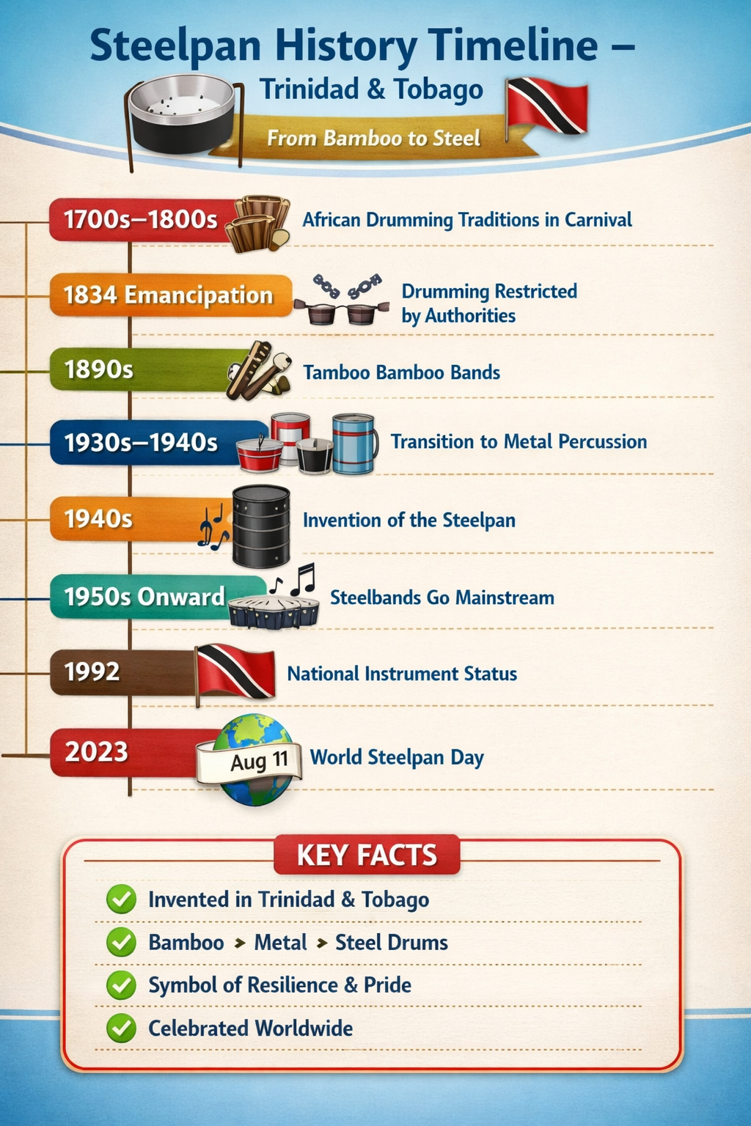https://copilot.microsoft.com/th/id/BCO.78b3dd5e-a43b-4d1c-91d5-

